**How to Block Self-Service Purchases of Windows 365 Licenses**

**Three Windows 365 Options Available for Purchase**

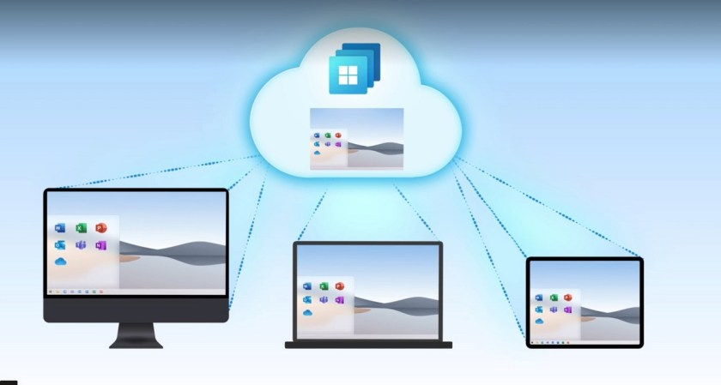Windows 365

[**Microsoft’s announcement of Windows 365**](https://news.microsoft.com/2021/07/14/microsoft-unveils-windows-365-ushering-in-a-new-category-of-computing/) on July 14 created a great deal of excitement in some organizations seeking a way to deploy and manage PC assets more easily (here’s [**an independent view on the topic**](https://practical365.com/windows-365-announced-and-azure-virtual-desktop-gains-new-features/)). Five days later, Microsoft notified Office 365 tenants in MC271483 that end users will be able to buy Windows 365 licenses through the self-purchase license mechanism in the Microsoft 365 admin center. By default, Microsoft enables self-service purchases of Windows 365 licenses, so if you don’t want this to happen, you must disable the self-purchase option for Windows 365 using PowerShell.

Windows 365 comes in two versions. Microsoft’s definitions for the two are:

* ***Windows 365 Enterprise****is for organizations that want to manage their Cloud PCs with Microsoft Endpoint Manager and take advantage of integrations with other Microsoft services, including Azure Active Director and Microsoft Defender for Endpoint.*
* ***Windows 365 Business****is for smaller organizations that want a simple way to buy, deploy, and manage Cloud PCs.*

According to Microsoft, self-service purchases are integrated into the two versions as follows:

* *Microsoft 365 Enterprise: IT admins who use Microsoft Endpoint Manager (MEM) will be able to purchase a license during the resize action on a user’s Cloud PC if their organization does not have any licenses available.*
* *Microsoft 365 Business: Any user can purchase a license from*[***windows365.com***](https://www.windows365.com/)*and automatically have a Cloud PC created for them.*

**Self-Service Purchase Options**

Three Windows 365 options are available for self-purchase. Microsoft won’t confirm prices until August 1.

* Windows 365 Enterprise (CFQ7TTC0HHS9).
* Windows 365 Business with Windows Hybrid Benefit (“).
* Windows 365 Business (CFQ7TTC0J203). Apparently, [**this two CPU, 4GB RAM, and 128GB of storage option**](https://www.theverge.com/2021/7/15/22578396/microsoft-windows-365-pricing-skus-monthly-subscription-cost) costs $31/month.

Self-service purchases are unavailable for government and academic tenants.

**Using PowerShell to Block Windows 365 Self-Service License Purchases**

Control over Windows 365 self-service license purchases uses the same mechanism as Power Apps, Power Automate, Power BI, Visio, Project Online, and (most recently) [**Power BI Premium and Power Automate with RPA**](https://office365itpros.com/2021/03/26/microsoft-increases-self-service-license-purchases/). Here’s what you need to do:

First, if your workstation doesn’t already have [**version 1.6 of the MSCommerce PowerShell module**](https://www.powershellgallery.com/packages/MSCommerce/1.6), download and install the module. After the installation finishes, run the *Connect-MSCommerce* cmdlet to connect to the Commerce endpoint, authenticating using a global tenant administrator account.

Connect-MSCommerce

You can disable each Windows 365 option separately. For instance, here’s how to disable Windows 365 Business:

Update-MSCommerceProductPolicy -PolicyId AllowSelfServicePurchase -ProductId CFQ7TTC0J203 -Enabled **$False**

To disable the three Windows 365 self-service purchase options, use this code:

**$Windows365Options** = @("CFQ7TTC0HHS9", "CFQ7TTC0HX99", "CFQ7TTC0J203")

**ForEach** (**$Option** **in** **$Windows365Options**) {

Update-MSCommerceProductPolicy -PolicyId AllowSelfServicePurchase -ProductId **$Option** -Enabled **$False** }

Finally, check the current enablement status for each product available for self-purchase with:

Get-MSCommerceProductPolicies -PolicyId AllowSelfServicePurchase

ProductName ProductId PolicyId PolicyValue

----------- --------- -------- -----------

Windows 365 Enterprise CFQ7TTC0HHS9 AllowSelfServicePurchase Disabled

Windows 365 Business with Windows Hybrid Benefit CFQ7TTC0HX99 AllowSelfServicePurchase Disabled

Windows 365 Business CFQ7TTC0J203 AllowSelfServicePurchase Disabled

Power Automate per user CFQ7TTC0KP0N AllowSelfServicePurchase Disabled

Power Apps per user CFQ7TTC0KP0P AllowSelfServicePurchase Disabled

Power Automate RPA CFQ7TTC0KXG6 AllowSelfServicePurchase Disabled

Power BI Premium (standalone) CFQ7TTC0KXG7 AllowSelfServicePurchase Disabled

Visio Plan 2 CFQ7TTC0KXN8 AllowSelfServicePurchase Disabled

Visio Plan 1 CFQ7TTC0KXN9 AllowSelfServicePurchase Disabled

Project Plan 3 CFQ7TTC0KXNC AllowSelfServicePurchase Disabled

Project Plan 1 CFQ7TTC0KXND AllowSelfServicePurchase Disabled

Power BI Pro CFQ7TTC0L3PB AllowSelfServicePurchase Disabled

**To Block or Not to Block**

Self-service licensing has its place in some organizations. Others consider it inappropriate and unhelpful to allow end users to drive what they consider should be organization-led purchasing. If you’re in the latter category, go ahead and run the couple of lines of PowerShell given above to block users. If not, consider how to educate people about how self-service licensing works and when it should be used.